Min size: 15

Max depth: 8

*********************************************************

Iteration: 0

1 trees percentage: 60.306871247498336%

1 trees: Total time: 2.3058457374572754

5 trees percentage: 82.52168112074716%

5 trees: Total time: 12.339397192001343

10 trees percentage: 93.3288859239493%

10 trees: Total time: 23.170830249786377

20 trees percentage: 97.93195463642428%

20 trees: Total time: 41.084038496017456

*********************************************************

Iteration: 1

1 trees percentage: 79.0527018012008%

1 trees: Total time: 1.7718727588653564

5 trees percentage: 93.66244162775183%

5 trees: Total time: 12.609392881393433

10 trees percentage: 90.06004002668446%

10 trees: Total time: 20.85985040664673

20 trees percentage: 97.93195463642428%

20 trees: Total time: 40.589038610458374

*********************************************************

Iteration: 2

1 trees percentage: 90.12675116744497%

1 trees: Total time: 2.758338451385498

5 trees percentage: 94.52968645763842%

5 trees: Total time: 13.66902232170105

10 trees percentage: 90.393595730487%

10 trees: Total time: 23.538929224014282

20 trees percentage: 91.79452968645764%

20 trees: Total time: 45.12712097167969

*********************************************************

Iteration: 3

1 trees percentage: 74.98332221480987%

1 trees: Total time: 2.526503562927246

5 trees percentage: 94.52968645763842%

5 trees: Total time: 12.192374467849731

10 trees percentage: 82.12141427618413%

10 trees: Total time: 19.81220531463623

20 trees percentage: 94.79653102068045%

20 trees: Total time: 38.35868191719055

*********************************************************

Iteration: 4

1 trees percentage: 98.99933288859239%

1 trees: Total time: 1.7590441703796387

5 trees percentage: 85.45697131420947%

5 trees: Total time: 10.351481437683105

10 trees percentage: 98.99933288859239%

10 trees: Total time: 20.788477182388306

20 trees percentage: 81.32088058705804%

20 trees: Total time: 42.572367906570435

_________________________________________________________

Average percentages:

1 trees: 80.694%

Average time: 2.224 seconds

5 trees: 90.14%

Average time: 12.232 seconds

10 trees: 90.981%

Average time: 21.634 seconds

20 trees: 92.755%

Average time: 41.546 seconds

Diagram shows the accuracy:

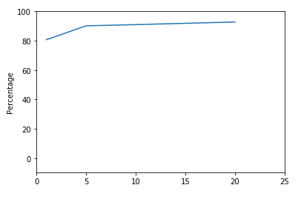

Diagram shows the time:

